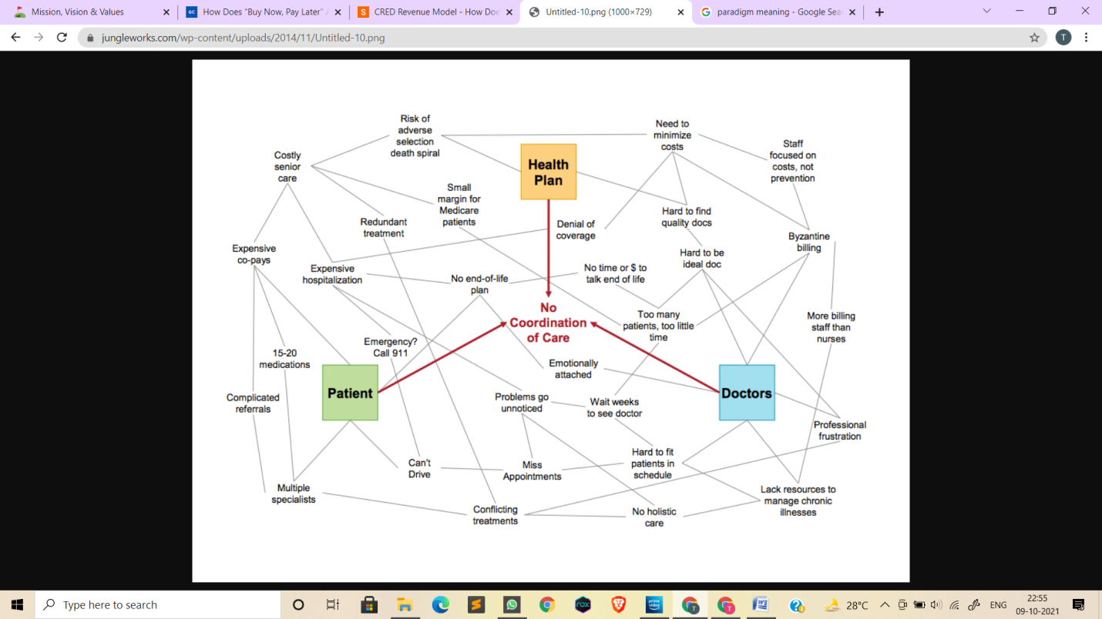

**Hassle maps are word clouds trying to map all existing challenges that impede a better customer experience in any industry.** Above is a description of the problems that an average customer faces in making health care choices while s/he is already paying a whopping 60% of these expenses out of pocket.

As you keep reading, you’ll soon have an epiphany; the same I had – healthcare landscape is set on the path to epic transformations; a paradigm (pattern) change precipitating at an accelerating pace aided by big data, e-commerce revolution and a transition into sharing economy.

This change, this web of ideas thrown in disarray above, is a euphemism (an indirect word or expression that you use instead of a more direct one when you are talking about something that is unpleasant or embarrassing) of the enormity of a challenge that belies the rapid evolution of this industry.